Virtual organization
AIS 211 (mangement studies)

Just a sample,
Not for direct use!
A virtual organization is a type of organization that operates primarily through electronic communication, rather than physical presence. In a virtual organization, employees, partners, and stakeholders collaborate remotely using digital tools such as email, video conferencing, project management software, and other online platforms.
Virtual organizations characteristics:
- Geographical dispersion: Members of a virtual organization may be located in different cities, countries, or even continents. This dispersion allows organizations to tap into a global talent pool and reduce overhead costs associated with maintaining physical office spaces.
- Flexibility: Virtual organizations often offer greater flexibility in terms of work hours and locations. Employees may have the freedom to work from home or other remote locations, allowing for a better work-life balance.
- Technology dependence: Virtual organizations rely heavily on technology to facilitate communication, collaboration, and project management. This includes tools such as email, video conferencing software, cloud storage, and project management platforms.
- Communication challenges: While technology enables communication across distances, virtual organizations may face challenges related to miscommunication, cultural differences, and lack of face-to-face interaction. Effective communication strategies and clear policies are crucial for overcoming these challenges.
- Agility: Virtual organizations can often adapt more quickly to changing market conditions and business needs due to their flexible structures and reliance on digital technology.
- Technology: Information networks facilitate remote collaboration through electronic contracts, speeding up partnerships.
- Opportunism: Partnerships are less enduring and more opportunistic, formed to exploit specific market opportunities.
- Excellence: Each partner contributes core competencies, potentially creating a best-of-everything organization.
- Trust: Partners rely heavily on each other, sharing a sense of co-destiny and requiring high levels of trust.
- No Borders: Traditional corporate boundaries blur as competitors, suppliers, and customers cooperate more closely.

Here is a flow chart showing a virtual organization,
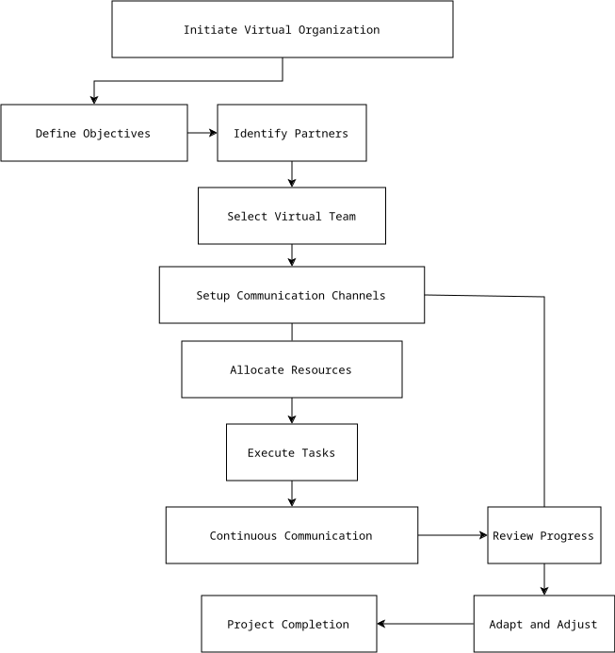
In this flowchart:
- The process begins with initiating the virtual organization, which involves defining objectives and identifying potential partners.
- Once partners are identified, a virtual team is selected to carry out the tasks necessary to achieve the objectives.
- Communication channels are established to facilitate collaboration and coordination among team members.
- Resources, including tools and technologies, are allocated to support the execution of tasks.
- Tasks are executed by the virtual team, with continuous communication and collaboration throughout the process.
- Progress is regularly reviewed, and adjustments are made as necessary to ensure the project stays on track.
- The process continues until the project is completed, at which point the virtual organization may disband or transition to new projects or objectives.
Overall, virtual organizations represent a modern approach to organizing work and can offer benefits such as cost savings, access to a global talent pool, and increased flexibility for employees. However, they also require careful management to ensure effective communication, collaboration, and coordination among team members.

Here are ten organizations in Bangladesh that operates in a virtual manner:
- Daraz Bangladesh (E-commerce platform)
- Pathao (Ride sharing platform)
- Grameenphone (Telecommunication company)
- Evaly (E-commerce platform)
- Techlution (Software development company)
- Ajkerdeal (E-commerce platform)
- Robi (Telecommunication company)
- TechRepublic Bangladesh (Digital marketing agency)
- 10 Minute School (Online education platform)
- Daraz seller point (Freelancing platform)

One of the most famous virtual organization
One of the most famous virtual organization is Upwork. It is one of the world's largest freelancing platforms, connecting businesses with skilled freelancers for various projects and tasks. Founded in 2015 through the merger of Elance and oDesk, Upwork has become a prominent platform for both freelancers seeking work and businesses seeking to outsource projects.

